Data Visualization using PowerBI Desktop

Exercise 4 –Visualizing Data using Microsoft PowerBI

Please use the screenshots ONLY as a reference. The instructions have to be followed AS-IS.
PLEASE MAKE SURE YOU SUBMIT ALL THE SCREENSHOTS WITH TIMESTAMPS AT THE BOTTOM RIGHT (WINDOWS USERS) OR THE TOP RIGHT (MAC OSX USERS) OR ELSE YOU WILL AUTOMATICALLY QUALIFY FOR A DISCOUNT.

Objective

The objective of this exercise is to develop skills on how to visualize the data set using PowerBI tool.
Prerequisite: Install PowerBI Desktop

Step 1: Download the provided CSV file from eLearning
In order to download and install the PowerBI Desktop, please click on the below link.
https://powerbi.microsoft.com/en-us/downloads/
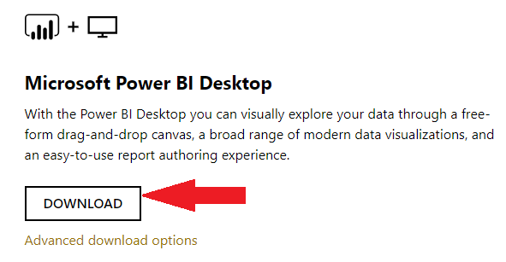

Click ‘Install anyway’
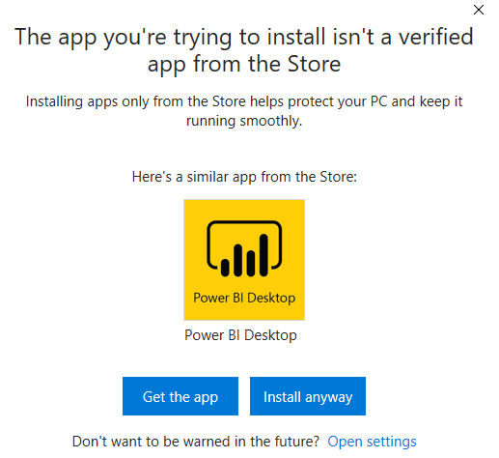
Note: You may or may not get different screen based on the version of your OS, or based on the app installation settings.

Click Next
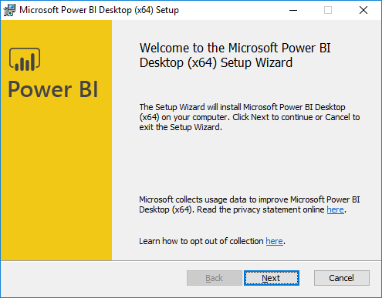

Read and accept the License Agreement
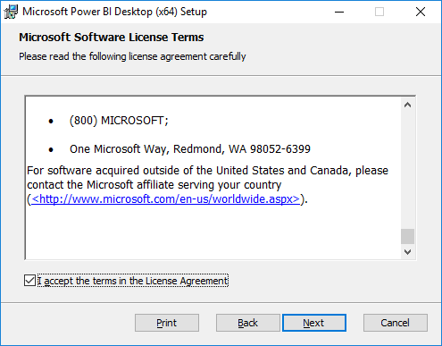
Provide the desired path of installation. You may keep the default.
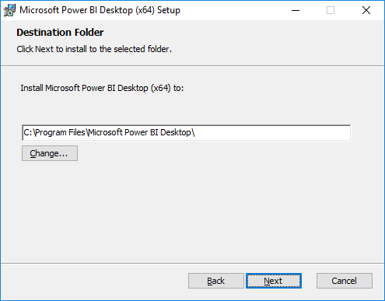
Click install
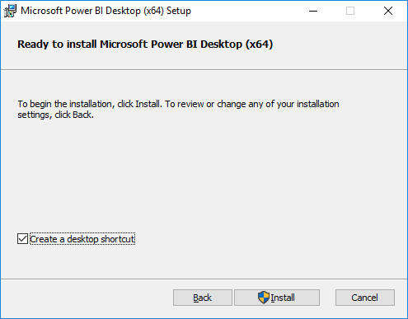

Step 2: Write the following python program in Jupyter Notebook
Purpose of this program is to format the data of the csv file and make it appropriate for PowerBI.
This python program will make following format changes in the downloaded csv file:
- It will merge the columns ‘Place’ and ‘State’ and make it one column with format ‘State-Place’
- It will transpose ‘Years and Population’ i.e. after running this python code the newly created csv file will have ‘Years’ and ‘Population’ as columns instead of rows
- A new column ‘Student First Name - Rank’ will be created which will rank the ‘State-City’ based on population.
Note:
You need to make following changes in the code:
- ‘Student First name’ in column ‘Student First Name - Rank’ should replace your First name
- While opening the file, you have to provide the location where you have downloaded the CSV file in Step-2.
- While writing the file, you need to provide a location where you want to save the newly created CSV file.

Following is the code for the above program:

Step 1: At first we import the libraries that we need to reference for the third party functions in our code.

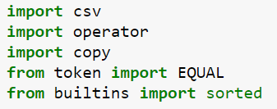

Step 2: We now read the CSV file that has been provided to you. Keep in mind the delimiter used in our CSV files is ','(comma). Don't stick to the notion that CSV's only use comma, they made use ' '(Tab), ';'(Semi-colon or maybe even a '^'(Caret)).

Step 3: This may be a little vague to you right now but we define a few variables which will determine the output file we generate from this unorganised CSV. The first 4 variables(u,x,y,z) represent the Columns our desired output file. 'rows_so_far' and 'c' are just 'counter' variables we'll be using in our loops later.

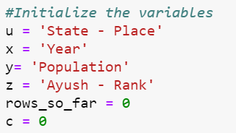

Step 4: For those of you who have a programming background, just skip reading this paragraph but for others, we are defining a 2D Array here and allowing it to get appended. Remember this as a swimming pool, you will throw a ball (in our case- a data row), your dog will go fetch it and put it in his toy basket(final list).

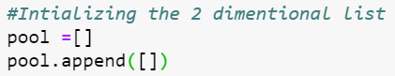

Note: Codes in Step 5 and Step 6 have to be in the same cell, else the loop won’t work

Step 5: Alright so now comes to complex part, there are 3 sub-Loops running underneath this loop, you have to be very careful with the indenting. Initially, we've got zero rows in our pool so let's put in the first row (Header) with the labels.

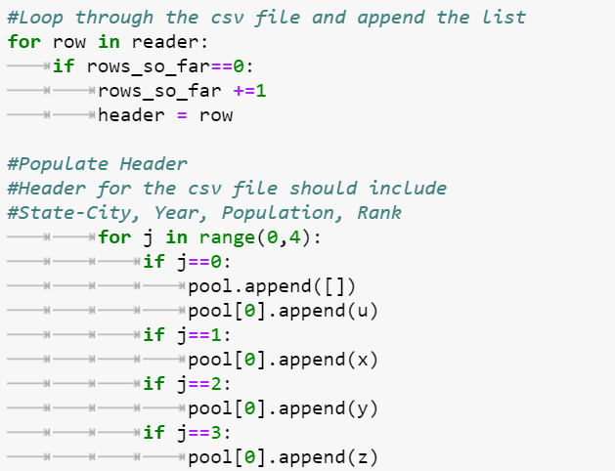

Step 6: Now after we're done populating the header, we will get into the main data records that we need. We now append population of a city for each year. We create a new variable 'a' which is the length of our 'pool' array, extremely helpful in verification and not overplotting. In nested loops, there are a lot of conditional verification steps using 'if-else' need to be carried out. '.deepcopy()' is just a simple copy function we import from the 'copy' library. At the end of the loop, our 'rows_so_far' variable is increased by 1. AGAIN, BE VERY CAREFUL WITH THE INDENTATION.

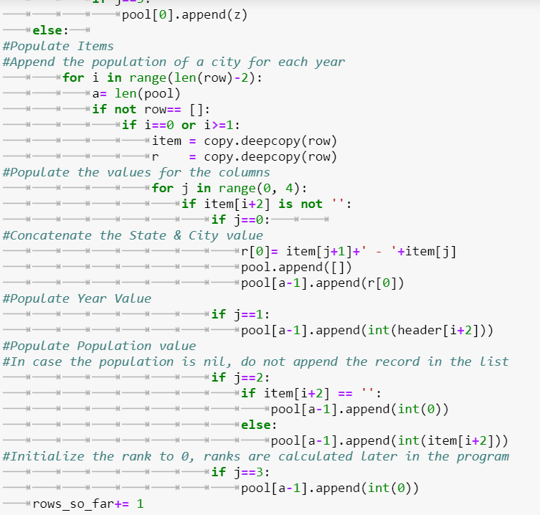

Step 7: Length of the 'pool' is verified after populating the sheet.

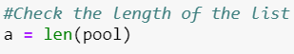

Step 8: We have to keep in mind that we don't populate the list including the header, hence 'a-1'. Also, sorting cannot be done on integer values when one record (header) has character value, hence we convert it to a 'list'.

Step 9: Here the list is sorted by year and population. The 'lambda' key is a simple one parameter anonymous callable function. In case of sorting, it can only do and return one thing. 'reverse' is an inbuilt python function which when true, sorts the list in DESCENDING order.

Step 10: We simply add the header to the list using proxy variables.

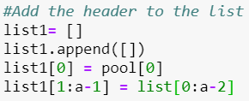

Step 11: 'csv.writer' is an output file function which creates a new CSV from the work done in the script. Here, we again use conditional verification using 'if-else' commands to make sure that our puzzle pieces(rows), fall into the right places. 'w' is a FILE MODE which creates text file for writing. If you were reading a file, you'd specifiy 'rb' (READ & Binary)

The name of csv file should be “FirstName.csv”
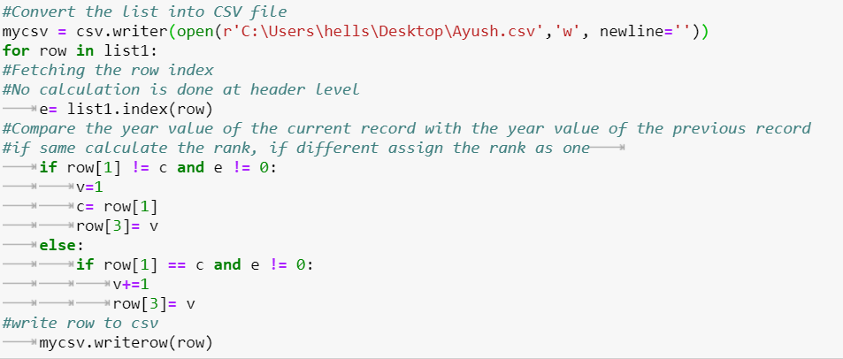

Note: Make sure that the lines of code are indented as shown in the above screenshot. Not having them indented might lead to errors or move lines of code out of the loop. Indentation should be a tab space and not a spacebar

Step 3: Save Program
Go to File, click on ”Rename”
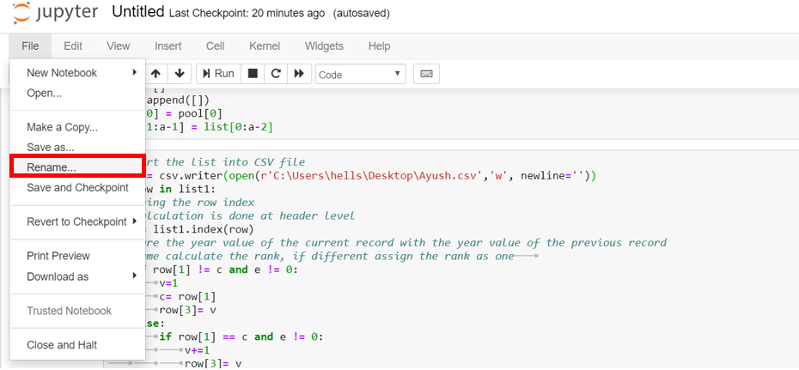

Rename it as Student_FirstName and click on “Rename” button

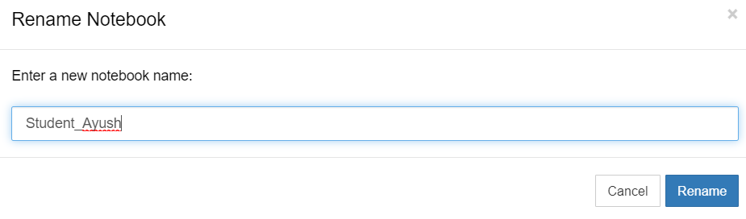
Finally click on the save icon as shown in the below screenshot.
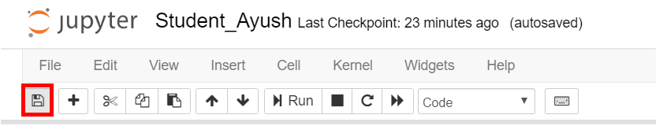

Note: Files are auto-saved in Jupyter Notebook. However, we did the above step to ensure it gets saved for sure.

Step 4: Check Output
The output file should be available at the path you have given in your python program

Output of the program would be a csv file and should look as below:-
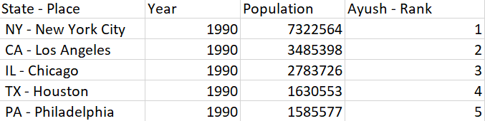

Question:
Open Microsoft excel and paste the screenshot of your file

Step 5: Open PowerBI desktop application
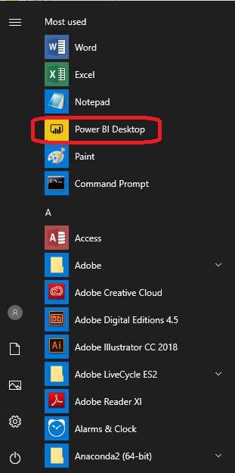
Close the sign-in option
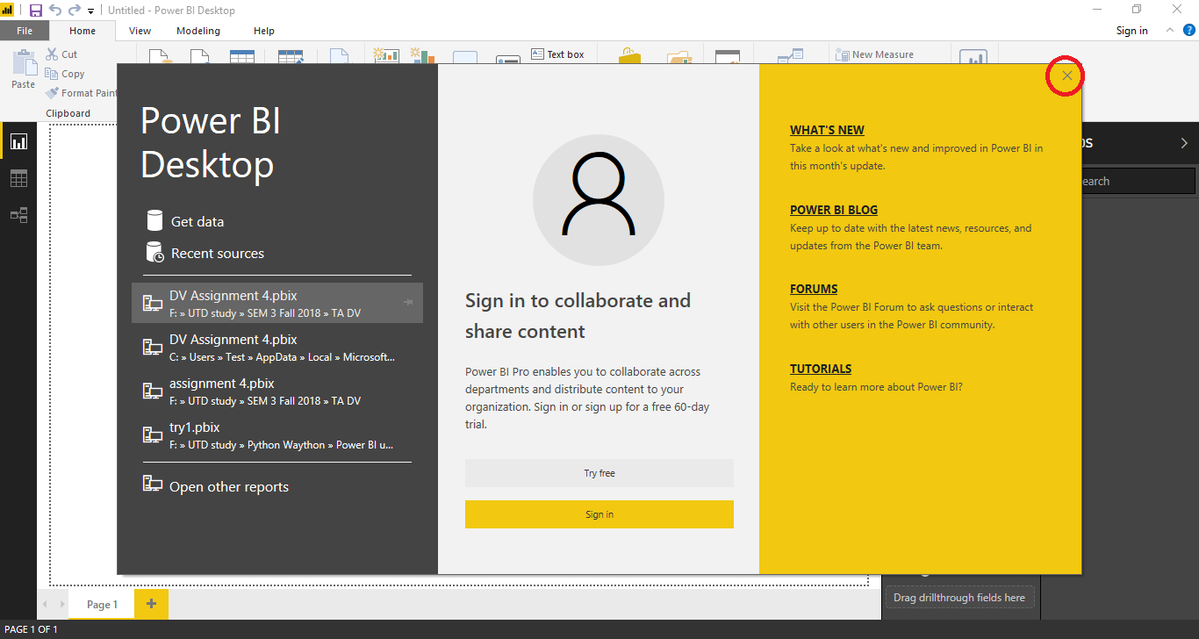

Step 6: Loading data
In Home ribbon click Get Data -> Text/CSV
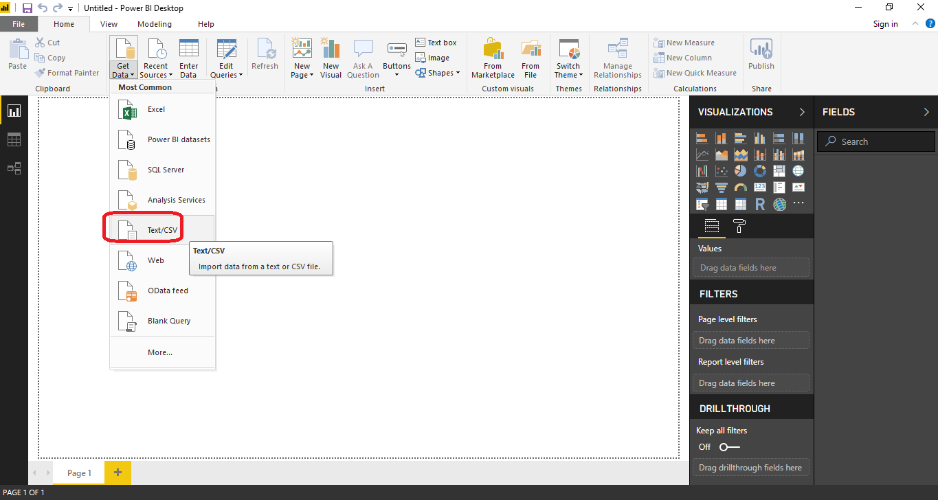

Question:Paste the screen shot of the load data screen.

Click load
Note: The student.csv in the below screenshot is same as FirstName.csv file created earlier
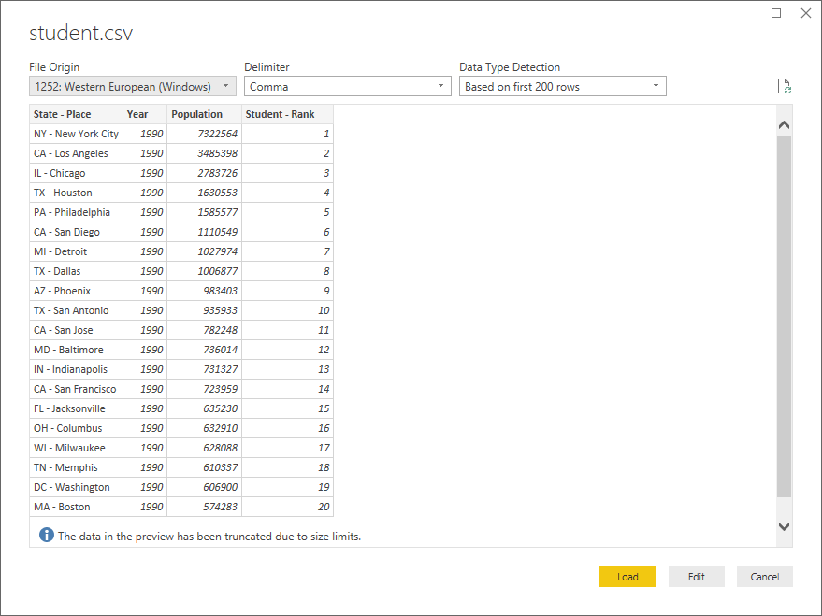

Step 7: Creating slicer (filter) of Rank
Select slicer from Visulization pane
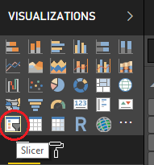
Select the Rank column you created as part of the previous code
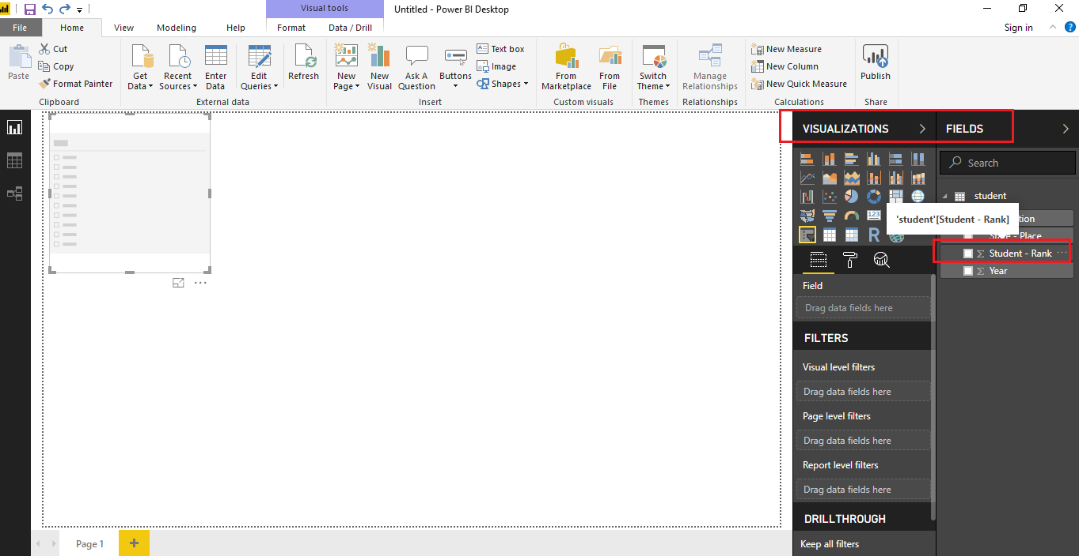

Position the rank slider to bottom right of the canvas
Question:
Paste the screen shot of the rank slider

Step 8: creating new measure
click more options and select new measure
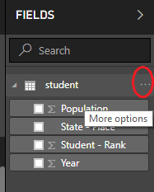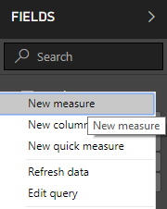

Configure the measure as: workforce = (SUM(student[Population]))*.60
Replace student with the name of your csv file
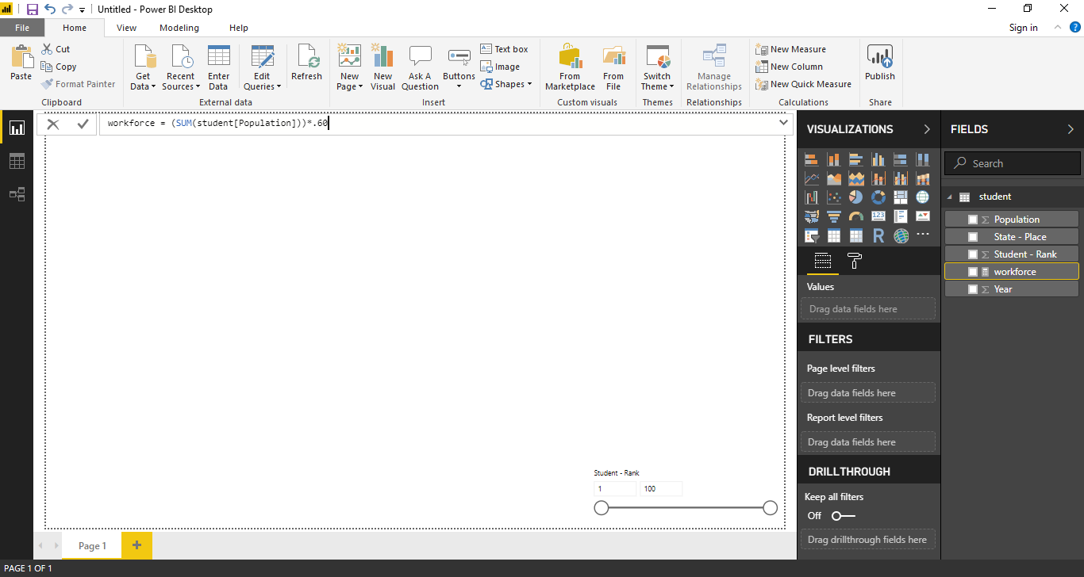
Click on green check mark after completion
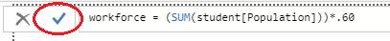
Question: Paste the screen shot of the newly created measure
Step 9: Preparing the Scatter Chart
Place the Scatter chart from Visulizations pane on the canvas
Maintain the following fields under the details section of the visulization:
- Drag Student-Rank from fields to X axis
- Drag Population from fields to Y axis
- Drag Work Force from fields to Size section
- Drag State-Place from fields to legend section
- Drag Year from fields to play axis
Expand the chart to fill the screen. Make sure the slider is visible too.

Question: Paste the screen shot of the chart

Change the slider to show top 5 ranks
Turn on the category labels under format
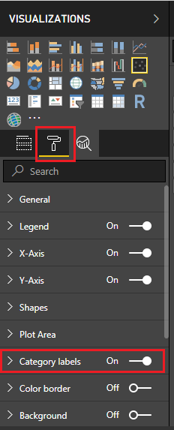
Question: Paste the screen shot of the chart

Step 10: Click on the play button to view how the population of cities change as we scan through the year.
Save the file as student_name.pbix.

Step 11: Download trial version of Camtasia software and record the video.
Go to the following link, click on the free trial option.
https://www.techsmith.com/camtasia.html
Sign in with your email and download the Camtasia software using the below link.
After downloading Camtasia, follow the below steps:-
- Open the downloaded file, it will start the installation process
- Accept the license agreement, in the setup
- Select the installation type as ‘Free Trial’
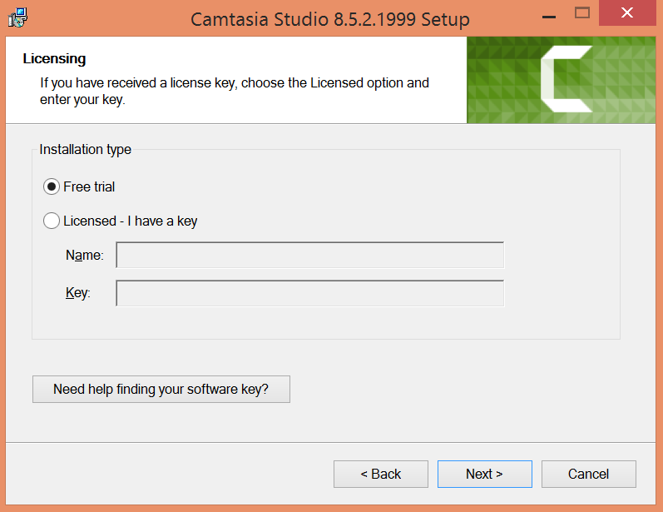

- Click on next button, and then click finish to complete the setup.
Step 12: Record the video in Camtasia
Open Camtasia, follow the below steps to record the video:
- On attempting to open the Camtasia, following message would be prompted, select the option highlighted in the screen shot and then click on finish.
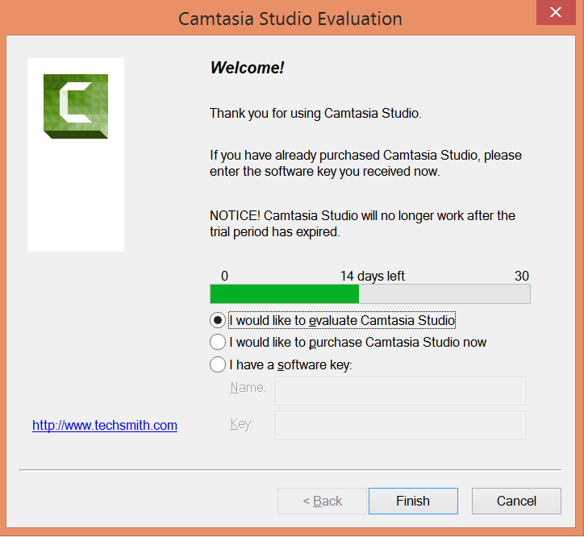
- Open the PowerBI file created in step 10.

- Click on record the screen button on the top left corner in Camtasia.
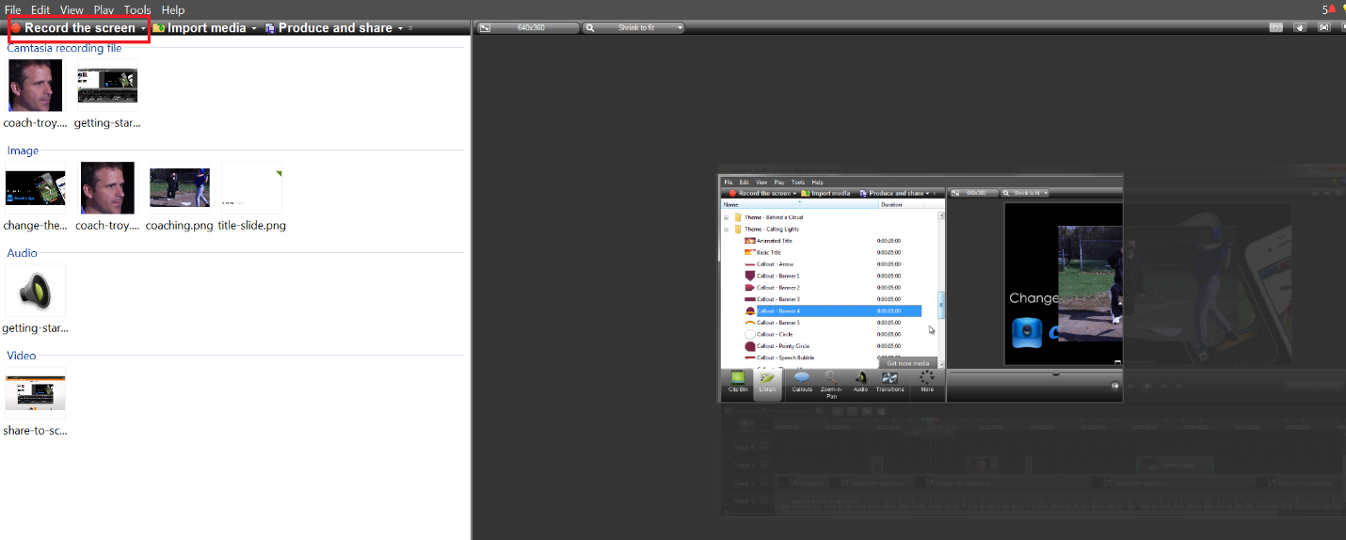

- Select custom in the following window
The green dotted line shows the area covered in the recording, increase or decrease the area to adjust to the size of the area to be recorded. By default the audio button is switched on, click on it to turn it off.

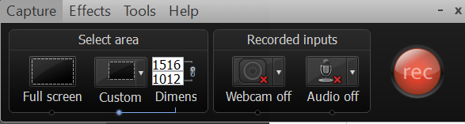

- Select the area in the PowerBI canvas that needs to be recorded. (represented by green dotted line)
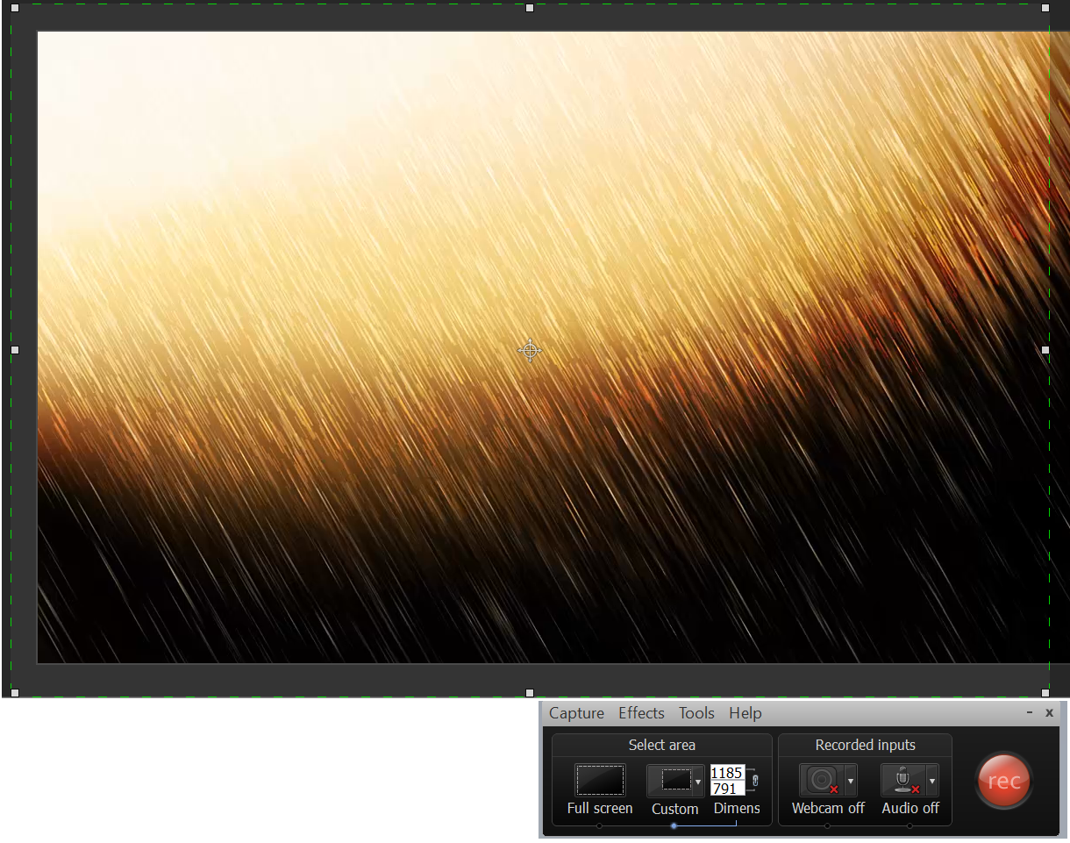

- Click on “Rec” button in the Camtasia window and then click play in the PowerBI visulization.

- Press the stop recording button, once the play axis scrolls through the end.

- Once the recording is complete, you would be able to view it in Camtasia. Click on Save & Edit button to save the recording.

- Video should be visible in the right side of the Camtasia window.

- In order to reduce the speed of the recording, right click on track 2 and select clip speed. By default the clip speed is 100, maintain it as 50 and then replay the video.
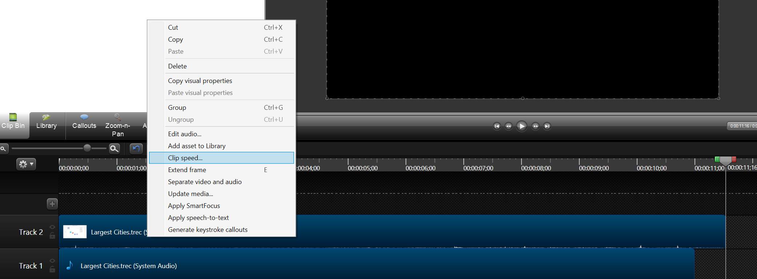

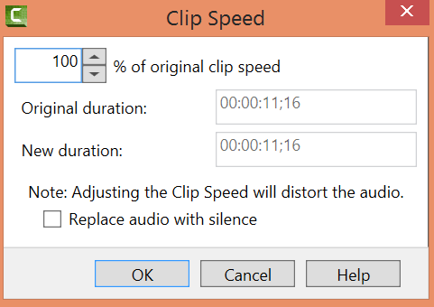

- Finally, save the project using the below menu path
File -> Save Project

Step 13: Attach assignments in elearning
- Attach the assignment document in Microsoft Word
- Attach the python .ipynb file created in step 3
- Attach the .pbix file created in Step 10
- Attach the Camtasia video created in Step 18 as a mp4 file type.

